

SRM Institute of Science and Technology
Faculty of Engineering and Technology
Department of Electrical and Electronics Engineering

Design Project Summary

Project Title : DIGITAL WATERMARKING OF AUDIO SIGNALS
FOR ENHANCED SIGNAL PROTECTION

Supervisor/Guide: Mr.C.Naveen
Team Members: 1.Gautam Nag
2.Shruti Srivastava

Background/Literature Review:

To digital watermark an audio signal some papers reffered are:
Some papers referred are:

- Yongge Wang: On the Design of LIL Tests for (Pseudo) Random Generators and Some Experimental Results. PDF
- Nicol, Tony (2015). "Statistical Properties of Pseudo Random Sequences and Experiments with PHP and Debian OpenSSL". Computers and Security. 53: 44–64. doi:10.1016/j.cose.2015.05.005.
- Knuth, Donald (1998). The Art of Computer Programming Vol. 2 : Seminumerical Algorithms. Addison Wesley. pp. 93–118. ISBN 978-0-201-89684-8.
- N. Suryana, Siaw-Lang Wong (2010). “An efficient compact Tchebichef Moment for image compression”: Information Sciences Signal Processing and their Applications (ISSPA), 2010 10th International Conference on
- S. E. Tsai and S. M. Yang, An Effective Watermarking Method Based on Energy Averaging in Audio Signals: Hindawi Mathematical Problems in Engineering Volume 2018

Objective:

The present wy of audio watermarking is quite prone to 3rd party breaches. So the main objective of our project is to develop a form of audio encryption that even when intercepted retains its encryption properties whilst maintaining the clarity of the audio being transmitted.
.
Requirements:

SL. NO. | NAME | MODEL | VALUE
1 | OS | Windows 7 and above | -
2 | RAM | 2GB and above | -
3 | Processing Power | 2.5GHz and above | -
4 | CPU | 4 Core | -
Technical Requirements:

The developers of this project will possess coding done in Matlab TM.
Engineering standards and realistic constraints in these areas:

Area | Codes & Standards / Realistic Constraints
Economic | This project does not entail any cost but an addition optional cost of hardware can reach a price point of Rs. 2000 (maximum).
Environmental | This project is not expected to entail any particular environmental consequences.
Social | This project aims for providing a better outlook to the privacy of a common man, hence for the welfare of the society.
Ethical | This project is not expected to entail ethical constraints.
Health and Safety | This project is not expected to entail health and safety constraints.
Manufacturability | This project cannot be easily replicated. In order to attain so would require a formal letter of approval from the autors of the project and complete schematics, software specifications, code - Matlab TM.
Sustainability | This project is not expected to entail sustainability constraints.

Realistic Constraints:

Mention clearly the realistic constraints (like cost effectiveness, miniaturization, area/speed limitations, etc.) set and the one achieved

Deliverables:

- Software interface with Matlab TM

Abstract:

In today's world we know the importance of encryption and privacy and with data being the most prized possession it is more important than ever to protect that data. Therefore for our project we are aiming at using this as our principal objective for protecting signal and audio during transmission. To do this will use digital watermarking and using a digital image/unique code superimposing the signal and then transposing that image as a watermark on the audio signal. Watermarking is a technique used to label digital media by hiding copyright or other information into the underlying data. The aim is to create a watermark that must be imperceptible or undetectable by the user and should be robust to attacks and other types of distortion. In our method, the watermark is kept as a digital image or if contingency arises a masked signal copy. It is then weighted in the time domain to account for temporal masking. We discuss the detection of the watermark and assess the robustness of our watermarking approach to attacks and various signal manipulations. We believe that doing so will uniquely enhance security of the audio signal.

Plot Output

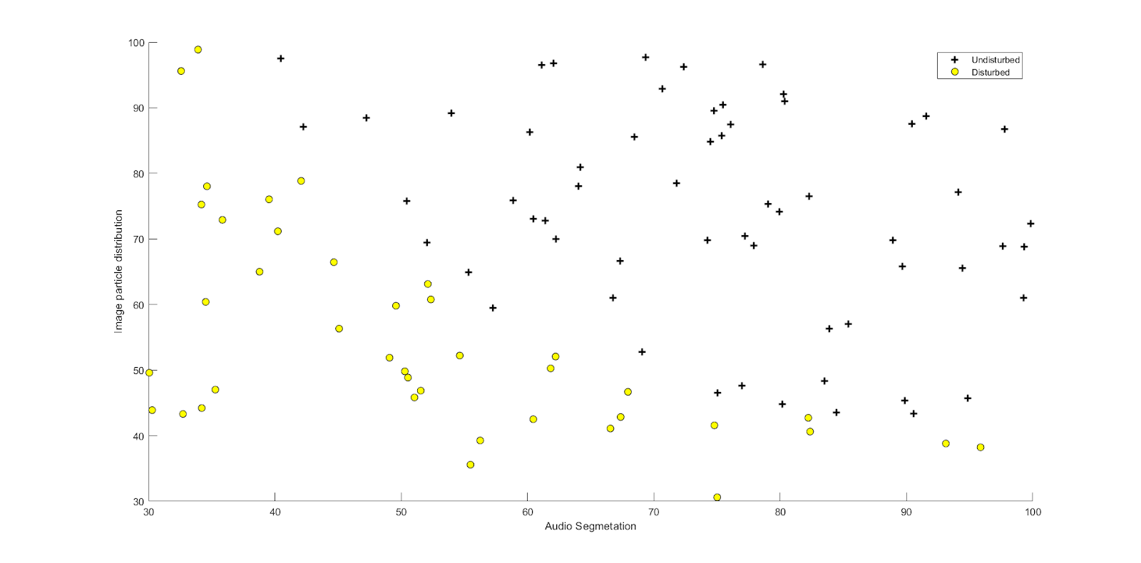

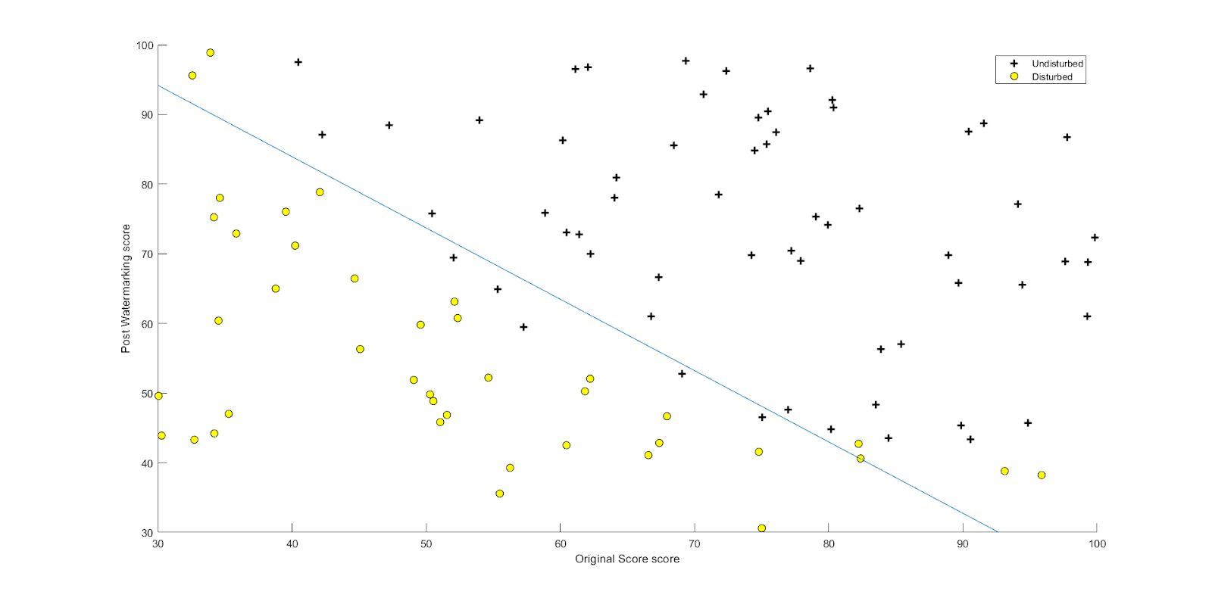

Additional Requirements:
None

